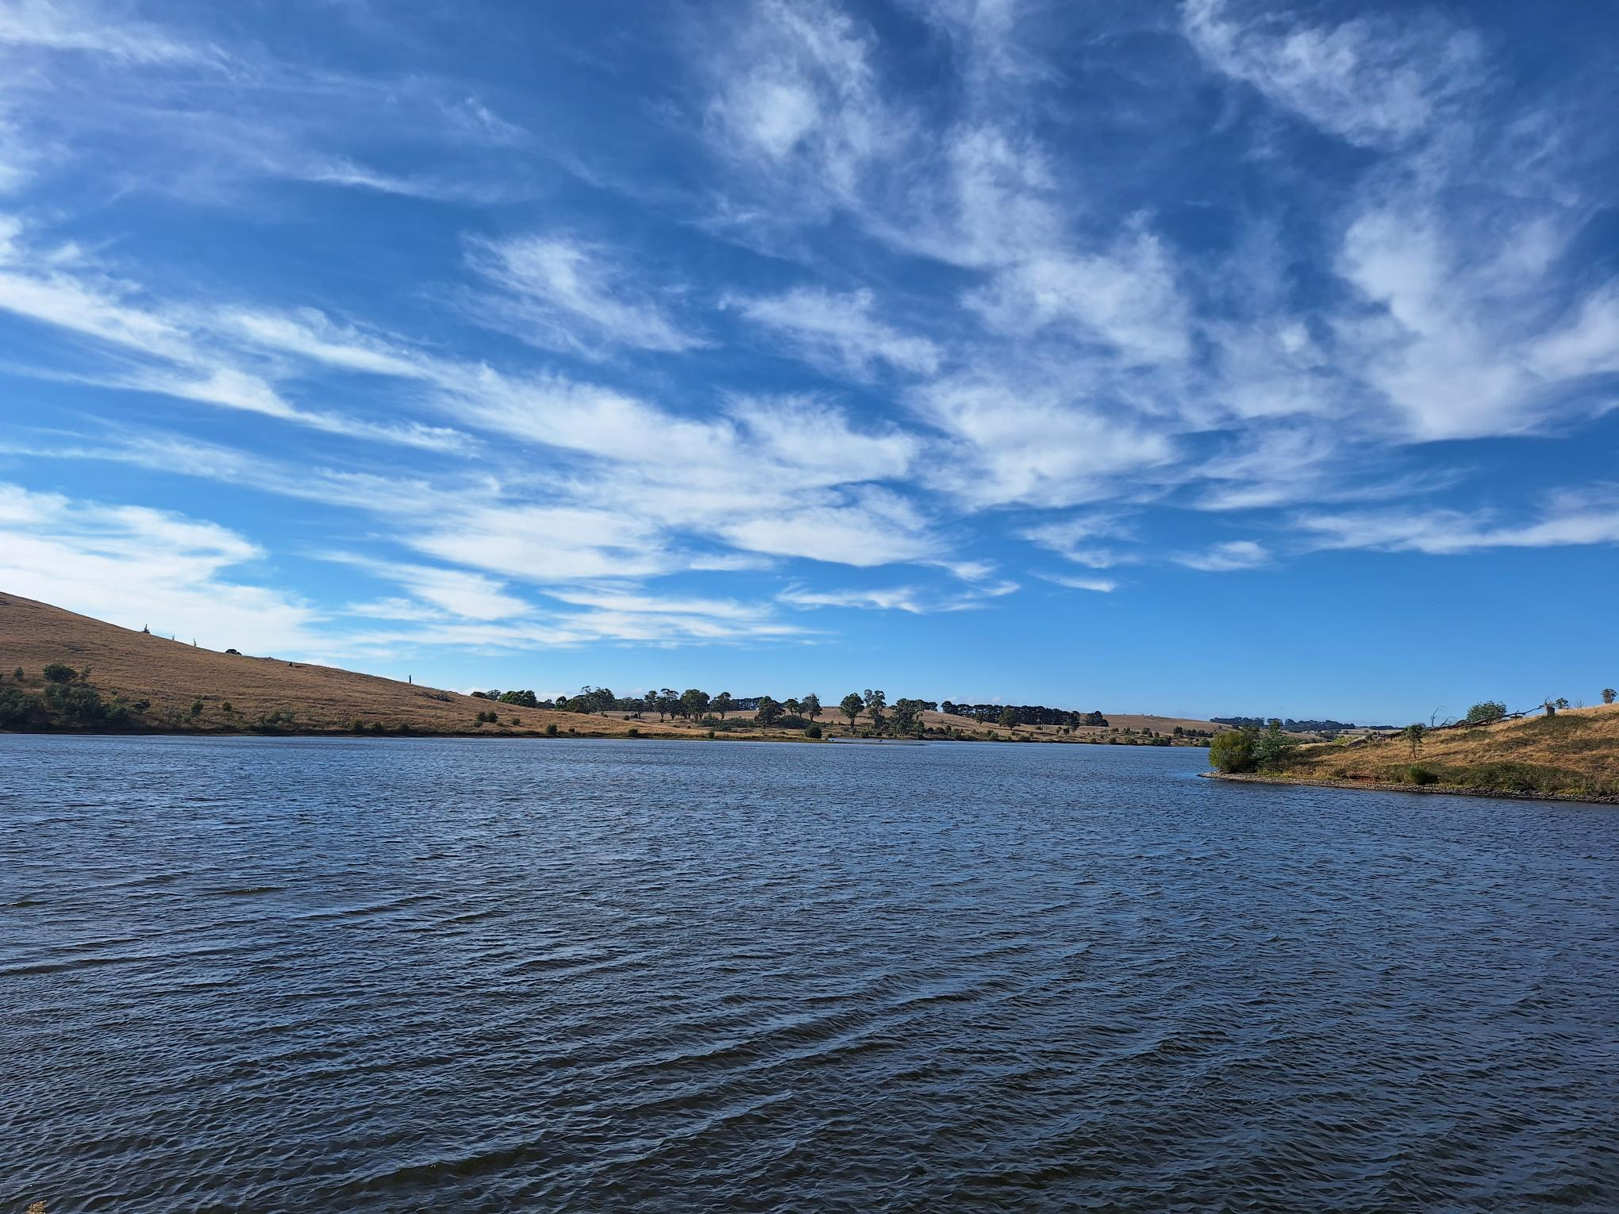
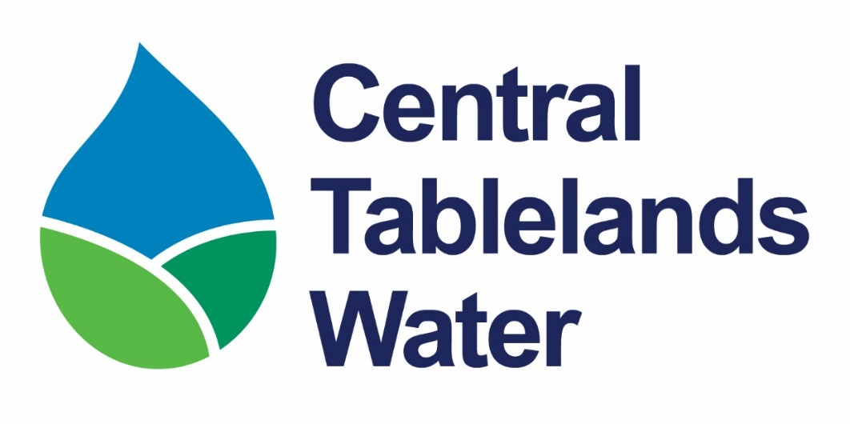
LABOURER, NETWORK OPERATOR
Recruitment Information Pack
WATER NETWORKS | MAINTENANCE | FIELD OPERATIONS | COMMUNITY SERVICE
Blayney, NSW • Full-time • Grade 2

Welcome to Central Tablelands Water
Thank you for your interest in joining  Central Tablelands Water (CTW)  Our people play a vital role in delivering safe, reliable, quality and affordable drinking water to communities across the Central Tablelands.  We are seeking a practical and safety-focused Network Operator to undertake routine operational, maintenance and installation activities across CTW’s water distribution network.  The Network Operator is a hands-on field position maintaining water mains, property services, hydrants, valves, reservoirs, pumps and pump stations, while recording operational information and supporting customers across the region.  If you value teamwork, integrity, safe work practices and meaningful work that directly supports local communities, I encourage you to apply.  Charlie Harris  General Manager | 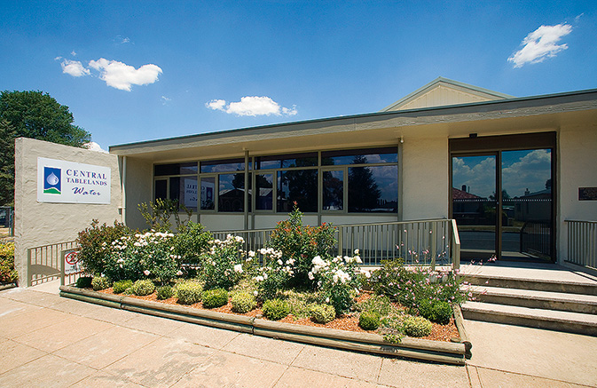  Central Tablelands Water Office, Blayney
Serving regional communities since 1944

Acknowledgement of Country
Central Tablelands Water is situated within the traditional lands of the Wiradjuri Nation. We acknowledge the Traditional Custodians of these lands and pay our respects to Wiradjuri Elders past and present. We recognise their continuing care and stewardship of Country.

About Central Tablelands Water
Central Tablelands County Council, trading as Central Tablelands Water (CTW), is a water supply authority constituted under the Local Government Act 1993 (NSW). CTW supplies drinking water to the Blayney, Cabonne and Weddin local government areas, and bulk water to Cowra Council.
15,000+  people supplied | 14  towns and villages | 6,000+  water connections
3  constituent councils | 1944  year first proclaimed | 1 purpose  quality, affordable water
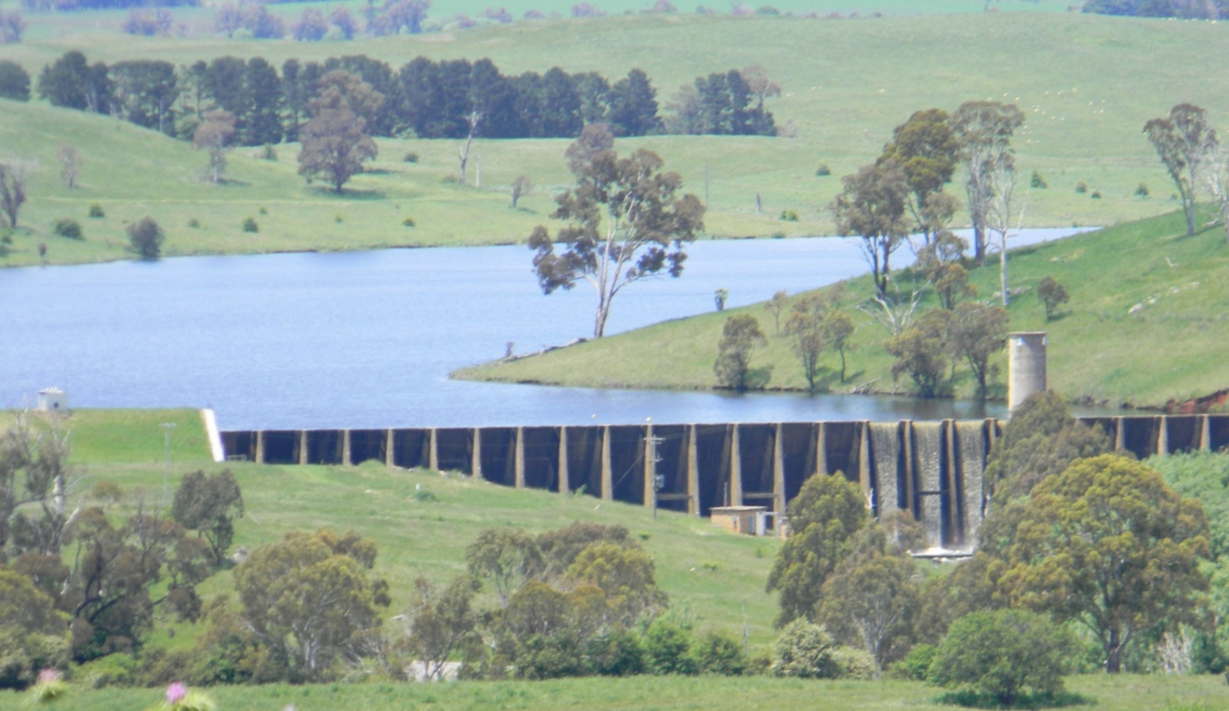

Our Direction
MISSION  Supply quality, affordable drinking water to our customers across our region, in collaboration with our constituent councils. | VISION  As a regional leader and provider, to achieve excellence in water supply, now and into the future. | VALUES  Our customers, our workforce, and our regional partners. We provide our water supply valuing sustainability, quality, efficiency, equity, and innovation

Why join CTW?
 | Make your work matter  Join a small, progressive regional water utility where the Network Operator’s practical contribution is visible and valued. Help maintain the infrastructure that delivers an essential service to households, businesses and communities.

What we offer
9-day fortnight  70-hour fortnight supporting work-life balance | Development  Role-relevant training and capability growth | Variety  Field work across water network operations and maintenance
Teamwork  Work alongside experienced network and technical staff | Purpose  Help deliver safe and reliable drinking water | Culture  Safety-focused, respectful and community-minded

Our team charter
- Champion CTW’s Mission, Vision and Values.
- Be open, honest, humble and professional.
- Collaborate, respect, trust and support each other.
- Honour commitments and remain accountable for results.

Live and work in the Central Tablelands
Based in Blayney, the role offers the benefits of regional living with convenient access to Orange and Bathurst. The Central Tablelands combines strong community connections, open spaces and an appealing regional lifestyle with access to established services and facilities.
Regional lifestyle  Open spaces, local communities and shorter commutes | Connected location  Convenient access to nearby regional centres | Meaningful career  Build local government experience while contributing locally

About the role
Network Operator | Operations and Technical Services | Reports to Water Network Manager
The Network Operator undertakes routine operational, maintenance and installation activities across CTW’s water distribution network to support the safe, reliable and efficient delivery of water services to customers. The Network Operator maintains network assets, records operational information, completes required documentation and carries out field-based duties in accordance with CTW’s policies, procedures and Work Health and Safety requirements.

Key responsibility areas
Network maintenance | Maintain trunk and reticulation water mains, hydrants, valves, property services and other network assets.

Installation and operations | Replace, repair, and install water meters, pumps, and pump stations.

Records and customer service | Read water meters, record operational data, complete required documentation, and communicate effectively with customers and colleagues.

Safety, equipment and improvement | Maintain plant, vehicles, tools and equipment in a safe and serviceable condition; comply with WHS requirements; and contribute to improved work practices.

A day in the role
No two days look the same
A typical day may involve checking plant, vehicles, tools and equipment before travelling to a field site to undertake manual labour to repair a water main, maintain a hydrant or valve, install a meter, or inspect a reservoir or pump station. The Network Operator also read water meters quarterly, record operational data, complete job-costing documentation, assist customers and work with colleagues to safely maintain or restore reliable water services.

The role will suit someone who can
- Work safely in field-based environments and follow procedures and directions
- Use practical judgement and common sense to solve routine operational problems
- Communicate clearly and respectfully with customers, contractors and work colleagues
- Complete routine records and operational documentation accurately
- Use mobile devices and position-related applications to enter and access field information
- Contribute to a positive workplace culture and demonstrate a safety mindset.

What you will bring

ESSENTIAL  - Higher School Certificate, or equivalent qualification  - 6 to 12 months’ relevant experience and/or training, or an equivalent combination of education and experience  - Ability to read water meters and interpret safety rules, operating and maintenance instructions, and procedure manuals  - Ability to prepare routine reports, records and correspondence  - Ability to communicate effectively with customers, contractors and work colleagues  - Ability to perform basic calculations, including rates, ratios and percentages, and interpret basic graphs and diagrams  - Ability to apply practical judgement and common sense when carrying out written, verbal or diagrammatic instructions  - Ability to solve routine problems in standardised work situations  - Basic ability to use smart devices and position-related applications or software  - Current NSW Class C Driver Licence | DESIRABLE  - Experience in water operations  - Relevant tickets or training, such as Construction Induction, Traffic Control, Confined Space Entry or First Aid  - Experience using electronic systems or mobile applications to record field data, complete work orders, enter meter readings or update maintenance records

Focus capabilities
Manage self • Display resilience and adaptability • Demonstrate accountability
• Communicate and engage • Community and customer focus • Work collaboratively

How to apply
We want to understand your experience, strengths and interest in the role.
1 Cover letter  Outline your interest and suitability by addressing each essential criteria in the position description. | 2 Resume  Include qualifications, employment history and at least two referees.

Submit your application
Email to hr@ctw.nsw.gov.au
Read the Recruitment Information Pack | www.ctw.nsw.gov.au/employment
Applications close | 5.00pm  Monday 21 September 2026
Remuneration | Grade 2: $63,807 to 76,696 (including super)
Enquiries | Lynette Safranek  Executive Manager Corporate Services  6391 7200

Recruitment process
APPLY  Submit all required documents | SHORTLIST  Applications assessed on merit | INTERVIEW  If successful, Blayney Office  28 September | CHECKS  Referees and  pre-employment medical | OFFER  Preferred applicant contacted

Equal opportunity and privacy
CTW is committed to a safe, inclusive and respectful workplace and welcomes applications from people of diverse backgrounds. Information collected during recruitment will be handled in accordance with applicable privacy requirements and CTW information management practices.

Be part of an organisation delivering one of life’s most essential services.

