
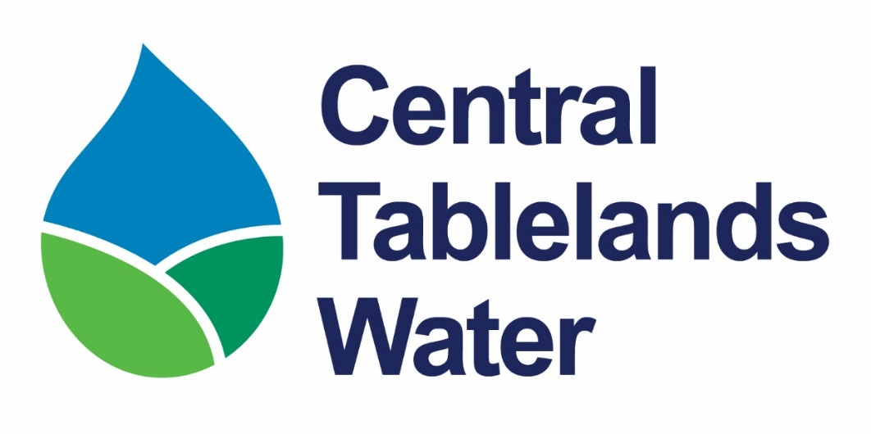
STORE PERSON AND OPERATOR
Recruitment Information Pack
STORES | PROCUREMENT | WATER OPERATIONS | COMMUNITY SERVICE
Blayney, NSW • Full-time • Grade 2

Welcome to Central Tablelands Water
Thank you for your interest in joining Central Tablelands Water (CTW)  Our people play a vital role in delivering safe, reliable, quality and affordable drinking water to communities across the Central Tablelands.  We are seeking an organised, practical and safety-focused Store Person and Operator to manage CTW store materials and support water network and water quality operations.  This varied position combines inventory control, procurement and supplier coordination with hands-on operational work across CTW’s water infrastructure.  If you value accuracy, teamwork, safe work practices and meaningful work that supports local communities, I encourage you to apply.  Charlie Harris  General Manager | 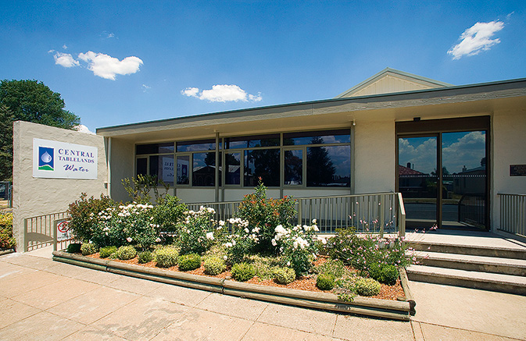  Central Tablelands Water Office, Blayney
Serving regional communities since 1944

Acknowledgement of Country
Central Tablelands Water is situated within the traditional lands of the Wiradjuri Nation. We acknowledge the Traditional Custodians of these lands and pay our respects to Wiradjuri Elders past and present. We recognise their continuing care and stewardship of Country.

About Central Tablelands Water
Central Tablelands County Council, trading as Central Tablelands Water (CTW), is a water supply authority constituted under the Local Government Act 1993 (NSW). CTW supplies drinking water to the Blayney, Cabonne and Weddin local government areas, and bulk water to Cowra Council.
15,000+  people supplied | 14  towns and villages | 6,000+  water connections
3  constituent councils | 1944  year first proclaimed | 1 purpose  quality, affordable water
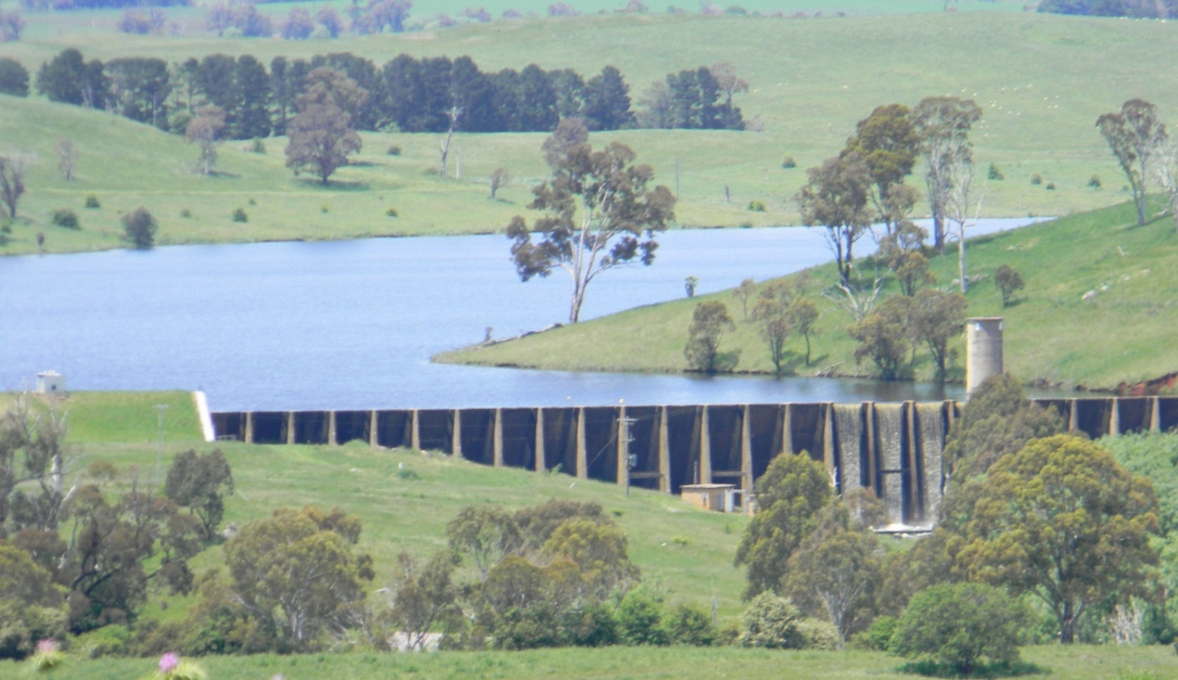

Our Direction
MISSION  Supply quality, affordable drinking water to our customers across our region, in collaboration with our constituent councils. | VISION  As a regional leader and provider, to achieve excellence in water supply, now and into the future. | VALUES  Our customers, our workforce, and our regional partners. We provide our water supply valuing sustainability, quality, efficiency, equity, and innovation

Why join CTW?
 | Make your work matter  Join a small, progressive regional water utility where the Store Person and Operator’s contribution is visible and valued. Help keep materials and equipment available for operational teams while also supporting essential water services in the field.

What we offer
9-day fortnight  70-hour fortnight supporting work-life balance | Development  Role-relevant training and capability growth | Variety  A mix of stores, procurement and operational field work
Teamwork  Work across stores, network and water quality activities | Purpose  Help deliver safe and reliable drinking water | Culture  Safety-focused, respectful and community-minded

Our team charter
- Champion CTW’s Mission, Vision and Values.
- Be open, honest, humble and professional.
- Collaborate, respect, trust and support each other.
- Honour commitments and remain accountable for results.

Live and work in the Central Tablelands
Based in Blayney, the role offers the benefits of regional living with convenient access to Orange and Bathurst. The Central Tablelands combines strong community connections, open spaces and an appealing regional lifestyle with access to established services and facilities.
Regional lifestyle  Open spaces, local communities and shorter commutes | Connected location  Convenient access to nearby regional centres | Meaningful career  Build local government experience while contributing locally

About the role
Store Person and Operator | Operations and Technical Services | Reports to Executive Manager Operations and Technical Services
The Store Person and Operator is responsible for procuring, receiving, distributing, recording and maintaining store materials, while also supporting the installation, operation, maintenance and repair of CTW water distribution and water quality infrastructure. The Store Person and Operator undertakes duties individually or as part of a team in accordance with CTW policies, procedures and Work Health and Safety requirements.

Key responsibility areas
Stores and inventory | Receive, inspect, unload, store and distribute materials; maintain inventory records; monitor stock levels; conduct stocktakes; and keep storage areas safe and orderly.

Procurement and deliveries | Procure materials and consumables within approved policies and delegations; coordinate deliveries; and verify purchase orders, invoices and supporting documentation.

Network and water quality operations | Assist with water network installation, maintenance and repair, distribution facilities, filtration facilities, water testing, meter reading and operational data.

Safety, service and teamwork | Safely operate plant, equipment, tools and vehicles; participate in on-call rosters and training; provide customer service; and comply with WHS requirements.

A day in the role
No two days look the same
A typical day may begin in the CTW Store receiving deliveries, checking documentation, updating inventory records and monitoring stock levels. The Store Person and Operator may then assist a network or water quality team with maintenance, repairs, meter reading, operational monitoring or water testing. The position also maintains safe storage areas, operates plant and equipment, and supports after-hours response through the on-call roster.

The role will suit someone who can
- Manage store materials, inventory records and procurement activities accurately
- Work safely with plant, equipment and tools in stores and operational environments
- Communicate clearly and respectfully with suppliers, contractors, customers and colleagues
- Perform manual handling and physically demanding tasks safely
- Use computer systems for inventory, purchasing and operational records
- Work independently and collaboratively while contributing to a positive, safety-focused workplace culture.

What you will bring

ESSENTIAL  - A minimum of 5 years’ experience in stores, warehousing, inventory control or a related operational environment  - Experience operating plant, equipment and tools safely  - Basic computer skills for inventory, purchasing and operational records  - Ability to perform manual handling and physically demanding tasks  - Ability to read water meters and interpret safety rules, operating and maintenance instructions, and procedure manuals  - Ability to prepare routine reports, records and correspondence  - Ability to communicate effectively with customers, contractors and work colleagues  - Ability to perform basic calculations, including rates, ratios and percentages, and interpret basic graphs and diagrams  - Ability to apply practical judgement and common sense when carrying out written, verbal or diagrammatic instructions  - Ability to solve routine problems in standardised work situations  - Basic ability to use smart devices and position-related applications or software  - Class C Driver’s licence with a safe driving record | DESIRABLE  - Experience in water operations  - Relevant tickets or training, such as Construction Induction, Traffic Control, Confined Space Entry or First Aid  - Experience using electronic systems or mobile applications to record field data, complete work orders, enter meter readings or update maintenance records

Focus capabilities
Act with integrity • Communicate and engage • Community and customer focus
• Deliver results • Assets and tools • Procurement and contracts

How to apply
We want to understand your experience, strengths and interest in the role.
1 Cover letter  Outline your interest and suitability by addressing each essential criteria in the position description. | 2 Resume  Include qualifications, employment history and at least two referees.

Submit your application
Email to hr@ctw.nsw.gov.au
Refer to the Recruitment Information Pack | www.ctw.nsw.gov.au/employment
Applications close | 5.00pm  Monday 21 September 2026
Remuneration | Grade 2: $63,807 to $76,696 per annum (including superannuation)
Enquiries | Lynette Safranek  Executive Manager Corporate Services  (02) 6391 7200

Recruitment process
APPLY  Submit all required documents | SHORTLIST  Applications assessed on merit | INTERVIEW  If successful, Blayney Office  28 September | CHECKS  Referees and  pre-employment medical | OFFER  Preferred applicant contacted

Equal opportunity and privacy
CTW is committed to a safe, inclusive and respectful workplace and welcomes applications from people of diverse backgrounds. Information collected during recruitment will be handled in accordance with applicable privacy requirements and CTW information management practices.

Be part of an organisation delivering one of life’s most essential services.

